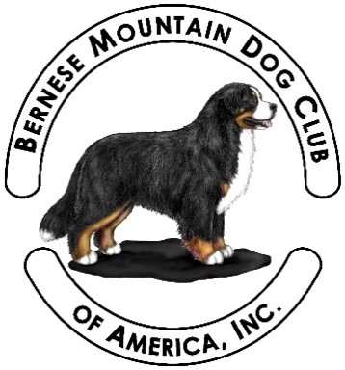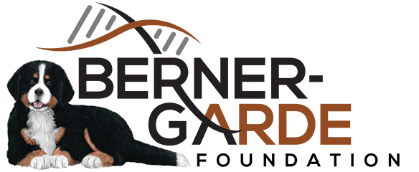**2026 BMDCA**

**Health Auction**

Name of Item:________________

Item Number: _________*(for office use only)*

Deed of Gift & Contribution Acknowledgement

1. **Count Me In!**

The Donor pledges that they own and will irrevocably give, transfer and assign, by way of gift, the following item or lot for sale at the 2026 BMDCA Health Auction.

1. **Description:** *Please* describe the item or lot in terms which may be helpful in the auction transaction. The description will be used in advertising for the Health Auction. You will also need to include a photograph of your item along with this form.
2. **Certificate of authenticity:**

____ None ____ Included with form ___ Donor will send ____ Software Generated

1. **Item Value:** *Please* indicate the estimated fair market value of the item or lot. $_______________
2. **Monetary Donation:** My donation is monetary in the amount of $___________________

Please write a check payable to The Berner-Garde Foundation. In the memo field put **2026 BMDCA HA**.

Mail the check and this form to:

The Berner-Garde Foundation, c/o Treasurer Robert Reeve

42220 Heaters Island Ct, Leesburg, VA 20176

1. **Donor Credit:**  Please state your name as you want it to appear in the auction’s printed materials or website.

______________________________________________________________________________

1. **Donor Contact Info: Address, email address, phone number:**

_____________________________________________________________________________

_____________________________________________________________________________

_____________________________________________________________________________

1. **Gift Deadline:** To ensure you and your gift are properly acknowledged in the Auction Program, please return this completed form and a photograph of *EACH* item

**no later than April 27, 2026**

to Health Auction delivery team member Jean Nielsen. Photos and forms can be sent by email to [jeannielsen6220@gmail.com](mailto:jeannielsen6220@gmail.com). The items will not be included if they don’t arrive in time for the auction. Please help us to be organized with your kind donations!!!

1. **Delivery:** Please include a COPY of this form with your package for tracking purposes.

**Mailed Items to: (*USPS, FedEx or UPS Delivery no later than April 27, 2026).***

Delivery Team Member:

Jean Nielsen

6220 Fernhill Road

Monmouth, OR 97361

(425) 681-2149

Jeannielsen6220@gmail.com

**Hand Delivered Items (\*\*\*\**Pre-Delivery as stated above to the Delivery Team Member is preferred*, accepting items during the show is very stressful).**

If the item will be brought to the Specialty, please arrange delivery for Monday May 11 or Tuesday May 12, 2026, by contacting Jean (at (425) 681-2149) to arrange a delivery time and place.

1. **Acknowledgement.**

The undersigned Donor intends to offer the gift for sale and that the proceeds of the sale shall be for the benefit of the BMDCA Health Auction 2026.

________________________________________________ _________________________

*Donor’s Signature Date*

Additional Information/Disclosures: The 2026 BMDCA Health Auction accepts the above gift for auction resale and affirms that no goods or services were provided to the Donor in connection with this gift. Items will either appear in the live auction or the silent auction.

Funds raised at the 2026 BMDCA Health Auction will support BMDCA Health Initiatives through the Fiscal Sponsorship Agreement between the BMDCA and the Berner-Garde Foundation.

***Please retain a copy of this completed form to be used in calculating your taxable credits***.

The Berner-Garde Foundation is a not-for-profit 501(c) (3) organization and as such your contributions may be tax deductible. The tax deduction is limited to the excess of the contribution over the fair market value of any items received in exchange for the donation.